This document explains how to create new email profile on your computer. If you have any difficulties during the process, please let IT know and we will help you to set up new profile. Please keep reading.

- You are about create new email profile for new email service we are planning to migrate.
- We will use the new email profile after email migration process begin.
- Until then we will keep using existing Outlook profile.
- Please do not delete existing email profile.
- We will come back to email profile setting to change default email profile later on. I will let you know when it should happen.

- First go to “Control Panel” then select “Mail” option
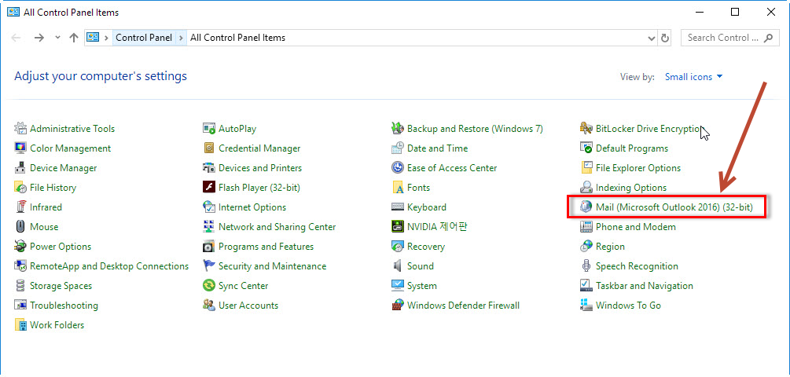

- Click Show Profiles
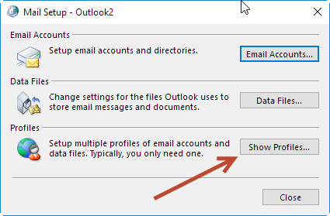

- In this case “Outlook2” is the default profile that you are using. Keep this profile intact. Click Add button.
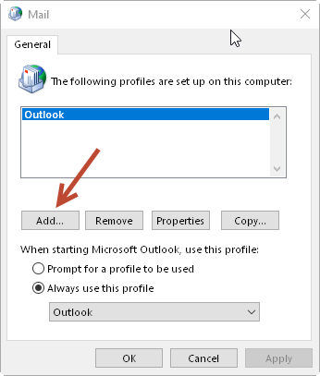
- In “New Profile” window, type “Office365” then click OK.
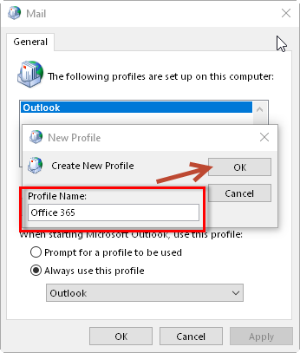
- In “Add Account” dialog box select manual set up and click “Next”
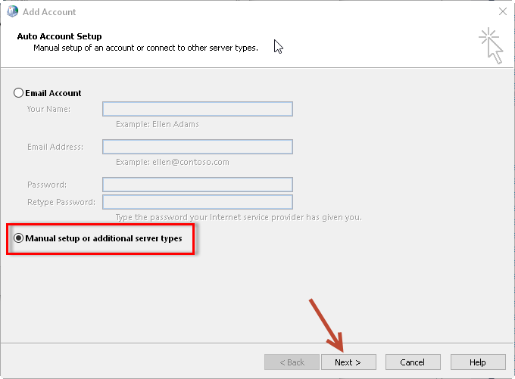6.
- Select “Office 365” as account type. Type in your current email address.
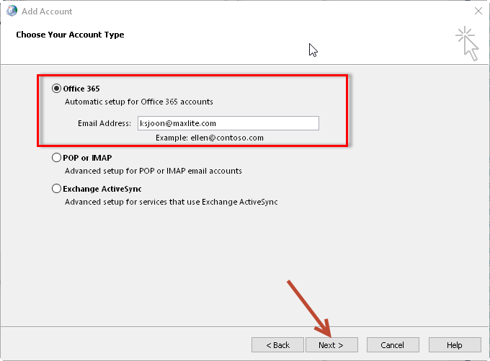

- It will attempt to find your configuration.
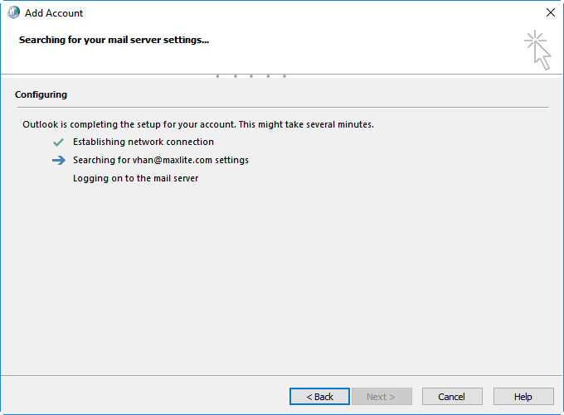
8. If it asked your credential, type your email address and Microsoft Teams password. Check “Remember my credentials” then click OK.
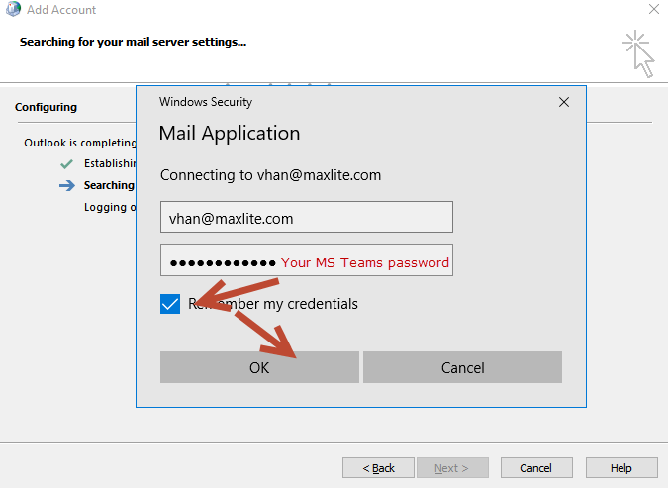

9. Click “Finish” button
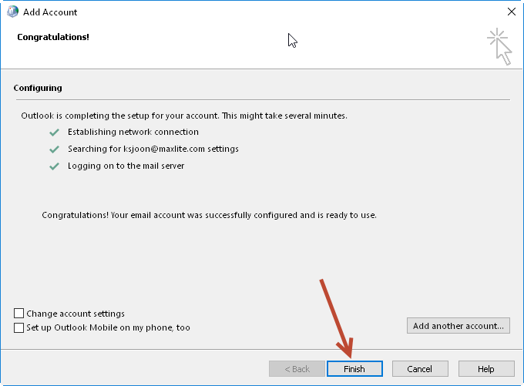
10. You will see new email profile added. We will use new profile when email migration is completed.
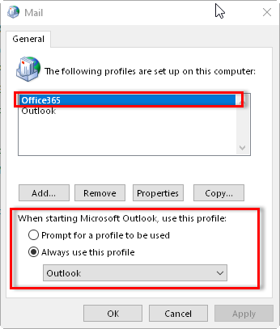
Now the important part.
Select your original email profile, “Outlook” in this case NOT “Office365”, to keep your original email configuration.
Choosing “Prompt for a profile to be used” will ask you select email profile whenever you start your Outlook.
Choose “Always use this profile” after selecting your original email profile. Once completed email migration, we will come back here and switch to new email profile.

