1. First go to “Control Panel” then select “Mail” option

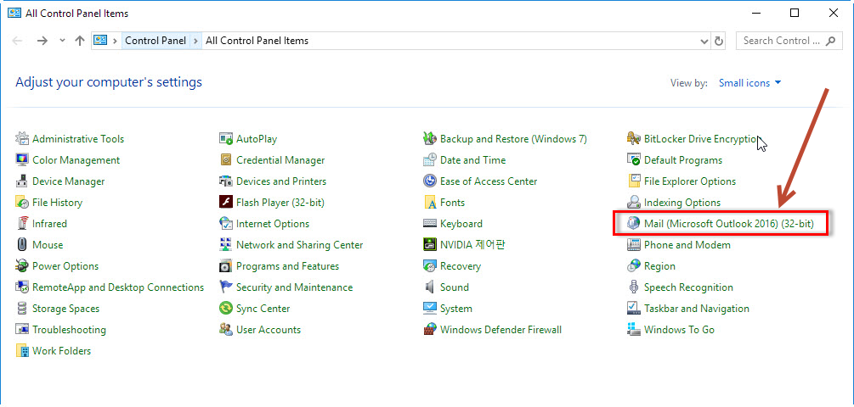

1. Click Show Profiles

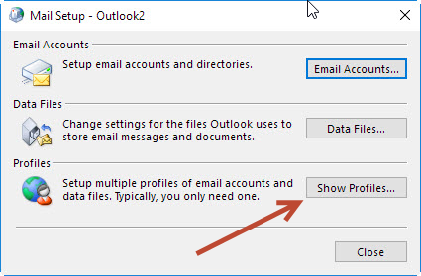

1. Please select “Office 365” profile and click OK. Start your Outlook to experience new email service.

